STEP BY STEP APPROACH OF MY Mobile-Lab1 Android Application

Following is the screenshot of MyApplication Welcome page which has 2 buttons:

\* Sign In

\* Sign Up

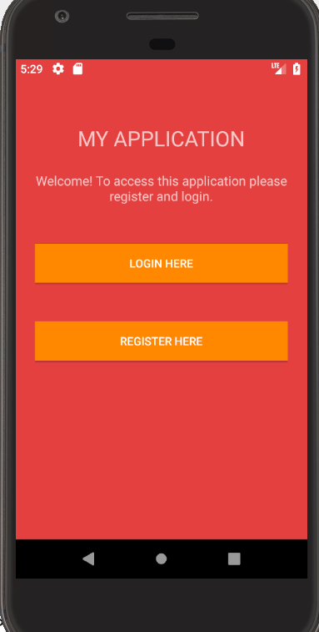

On clicking on "LOGIN HERE" button navigates to "Login Page" and on clicking on "REGISTER HERE" button navigates to "Register Page", Following is the screenshot of my Login Page:

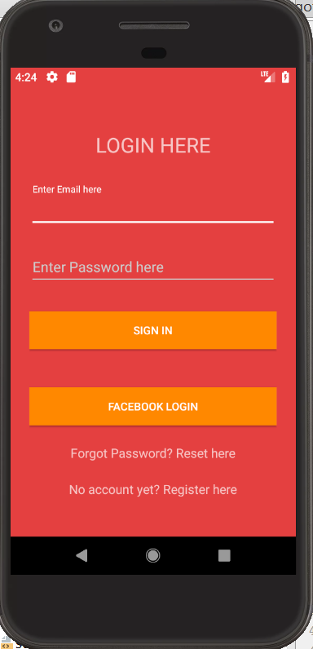

My "Login Form" page implements features like:

\* Manual Login

\* Social Login

\* reset Forgot Password

\* Register new users

On logging with wrong details generates an alert saying "Login Failed"

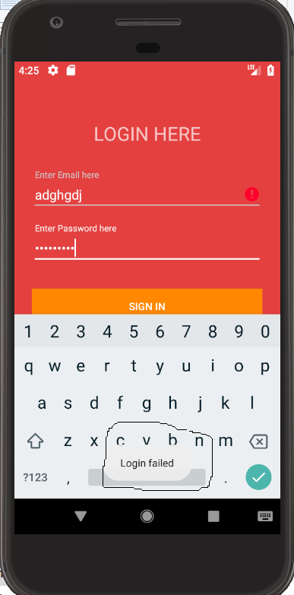

Following is the screenshot of my Register Page:

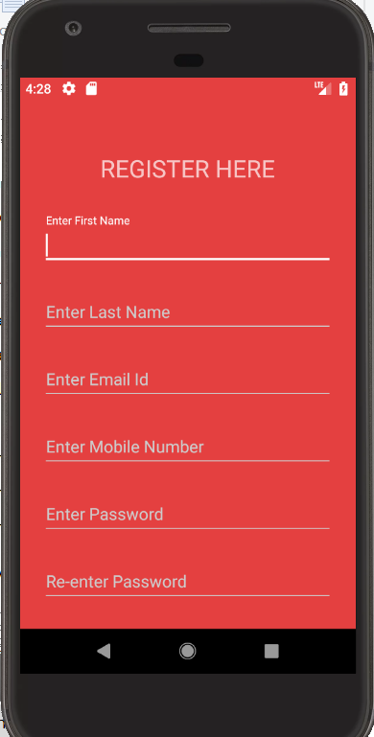 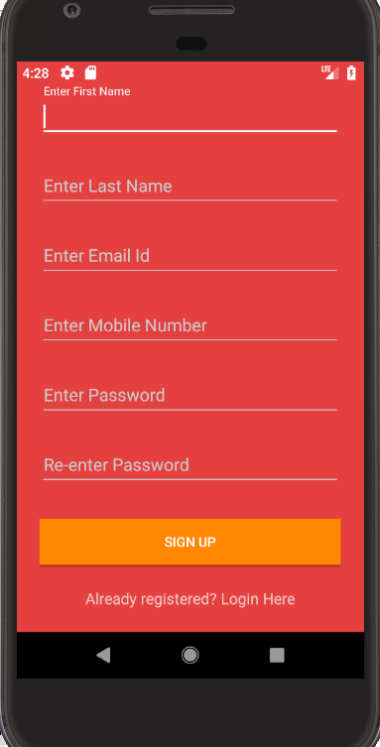

The user can fill the form and after successful registration, this page is navigated to "Login Page"

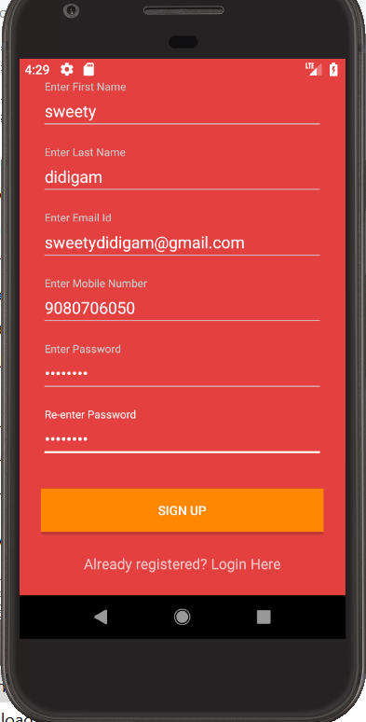 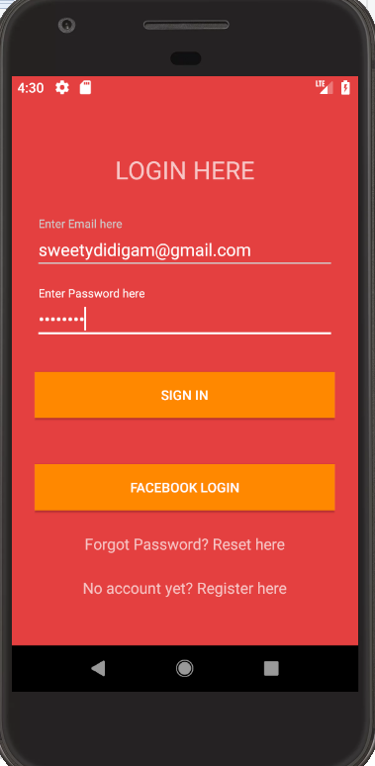

Application authenticates the details and logged into the application

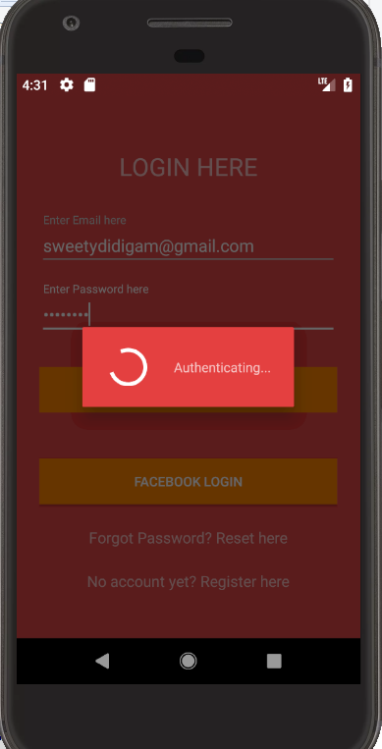

The user can use "Forgot Password?" to reset the password:

Following is the screenshot of "SET PASSWORD" page

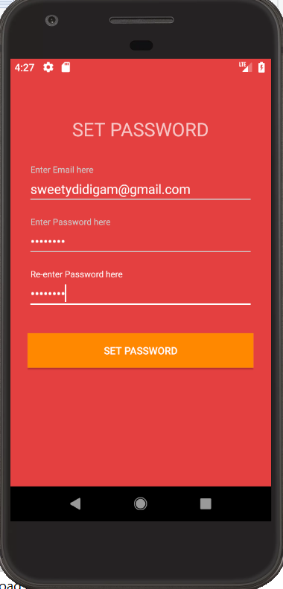

After successful login, it takes the User to Index Page

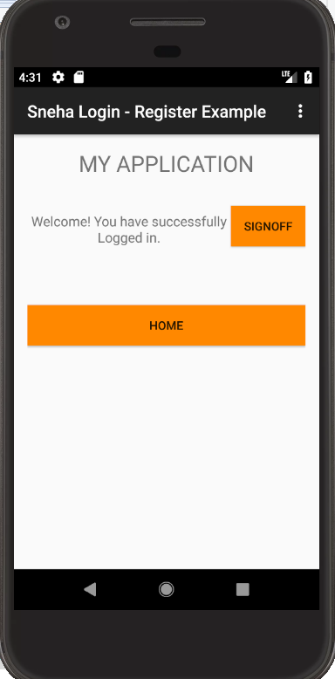

A user can choose "Login through Facebook" option from Sign in page



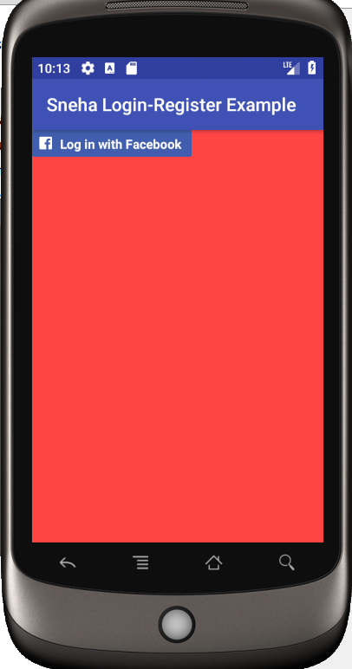 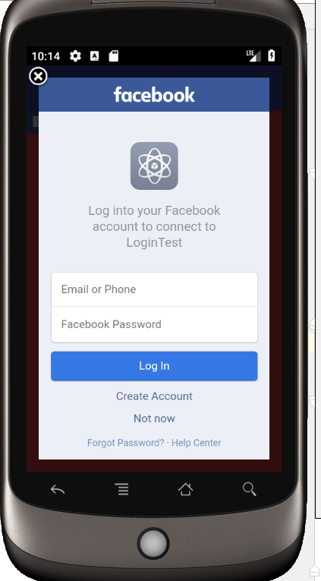

After entering login information on Facebook We can login to our application

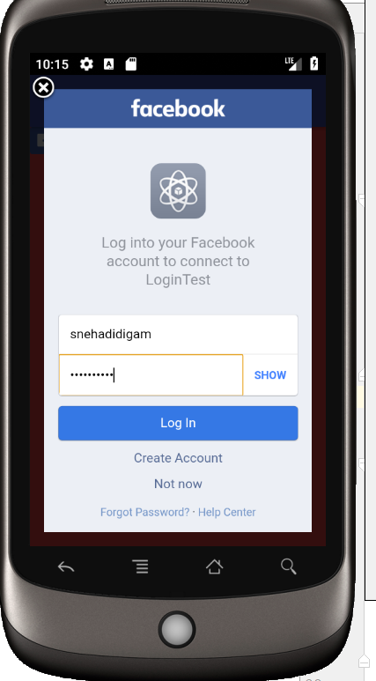 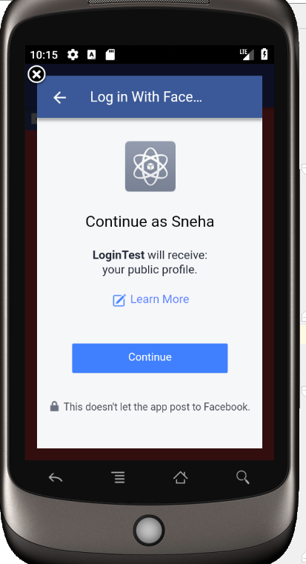

On clicking “Continue” will allow to use Android Application.